**ASSIGNMENT(27-12-2023)**

In this program we are converting existed data into list in pyspark environment with help of SparkSession finally displaying data

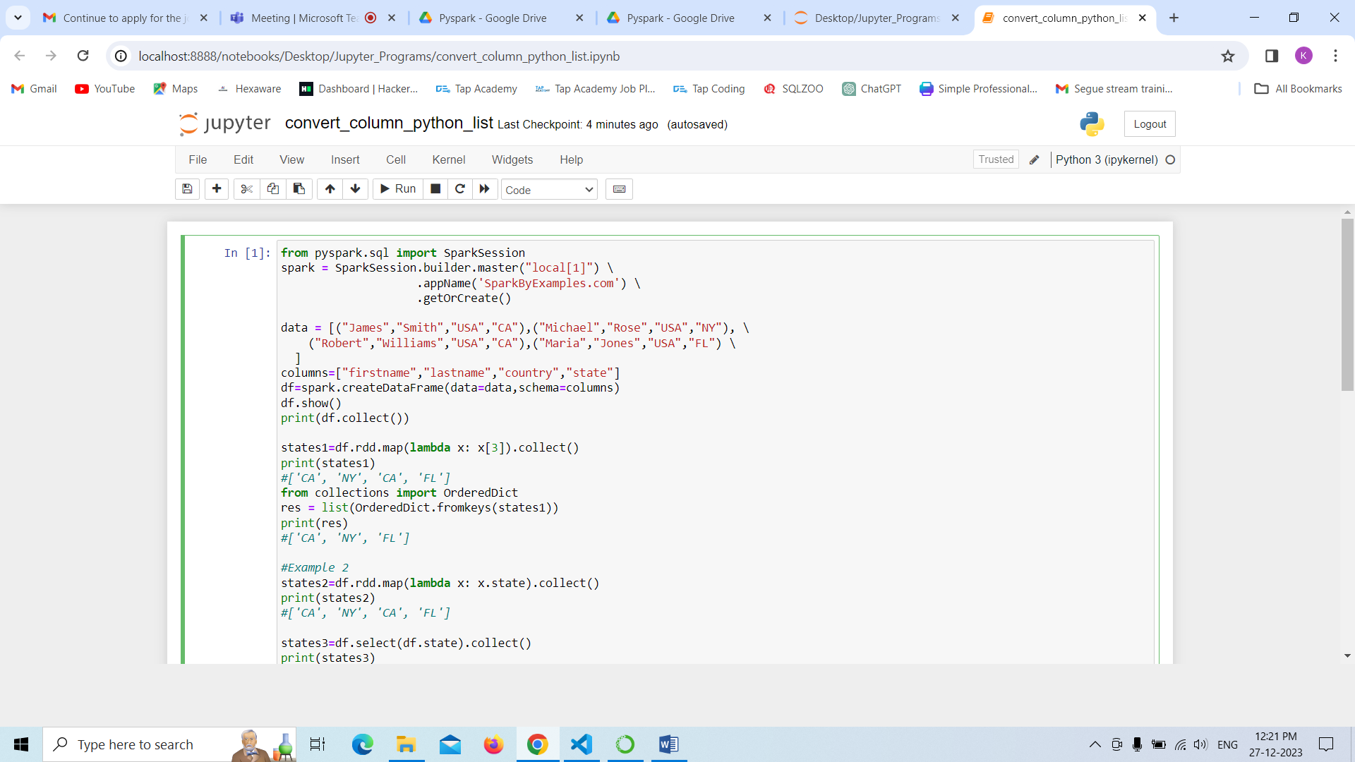

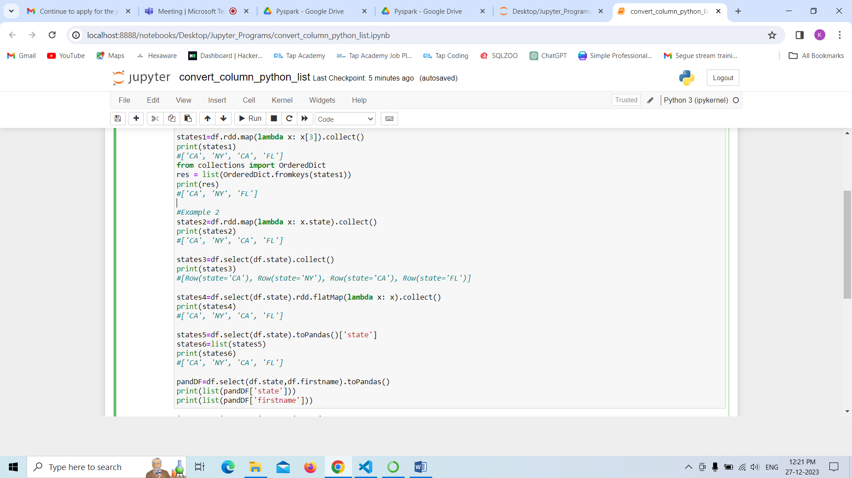

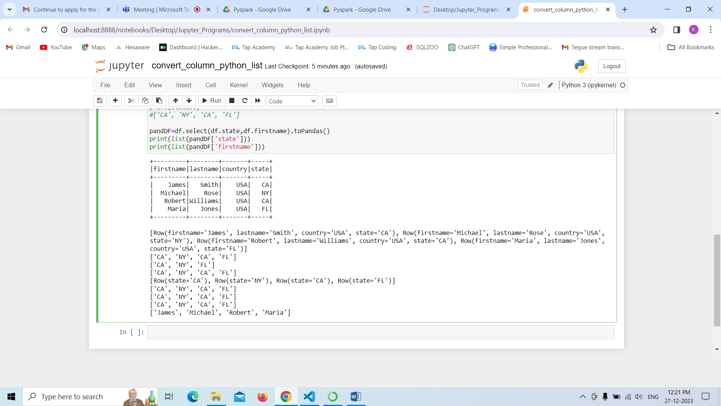

In this program we are creating a pandas dataframe in pyspark environment with help of SparkSession and adding the data into it and finally displaying result in structured table as output.

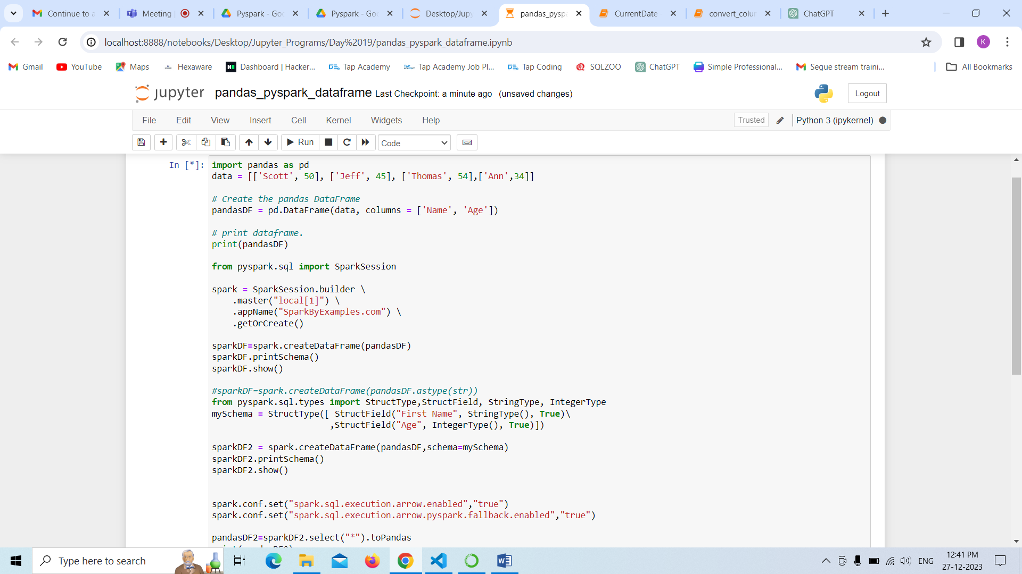

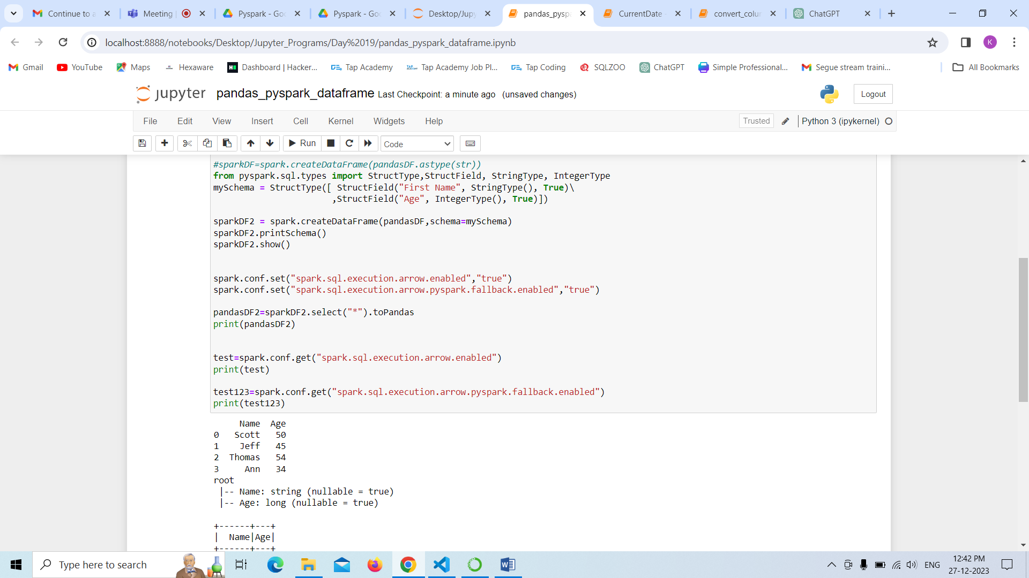

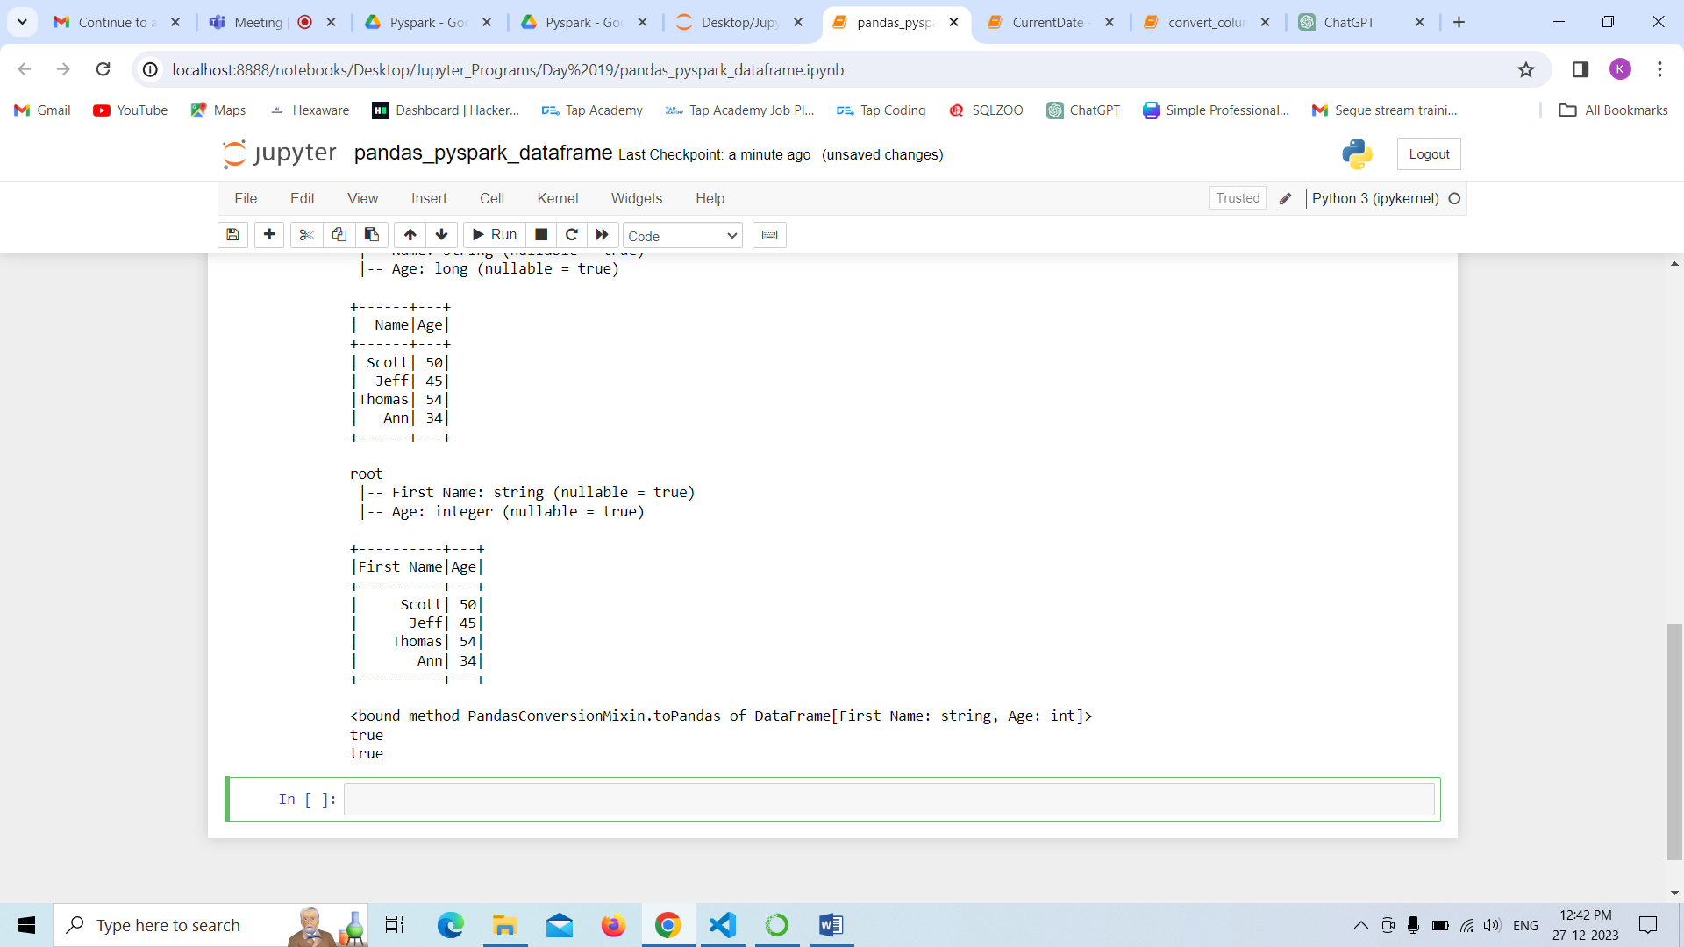

In this program we are adding a month to the existing date and also mentioning how many months that we are adding to the table in pyspark environment with the help of SparkSession and finally got the result as output in the form of date format.

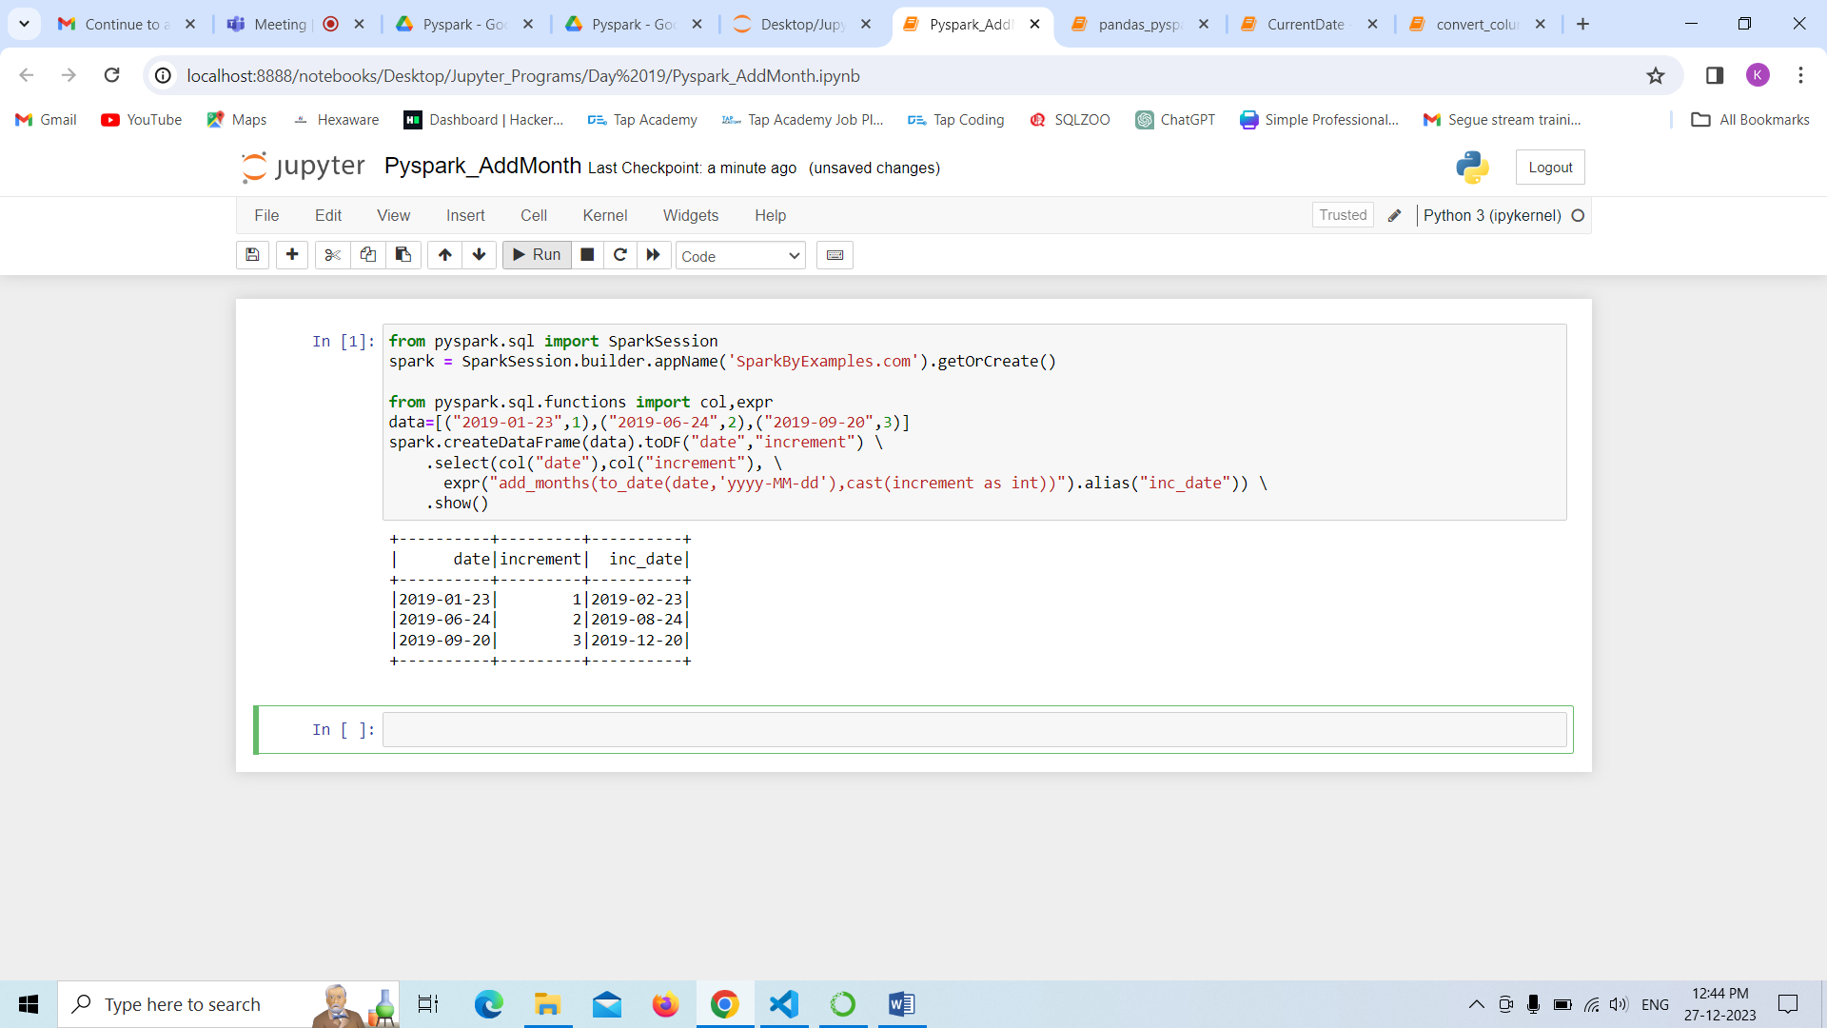

In this program we are adding new column to the existing table in the pyspark environment with the help of SparkSession Class.We are adding the column and displaying each record which are already existed with the help of select statement and we are calculating aggregating functions and displaying data.

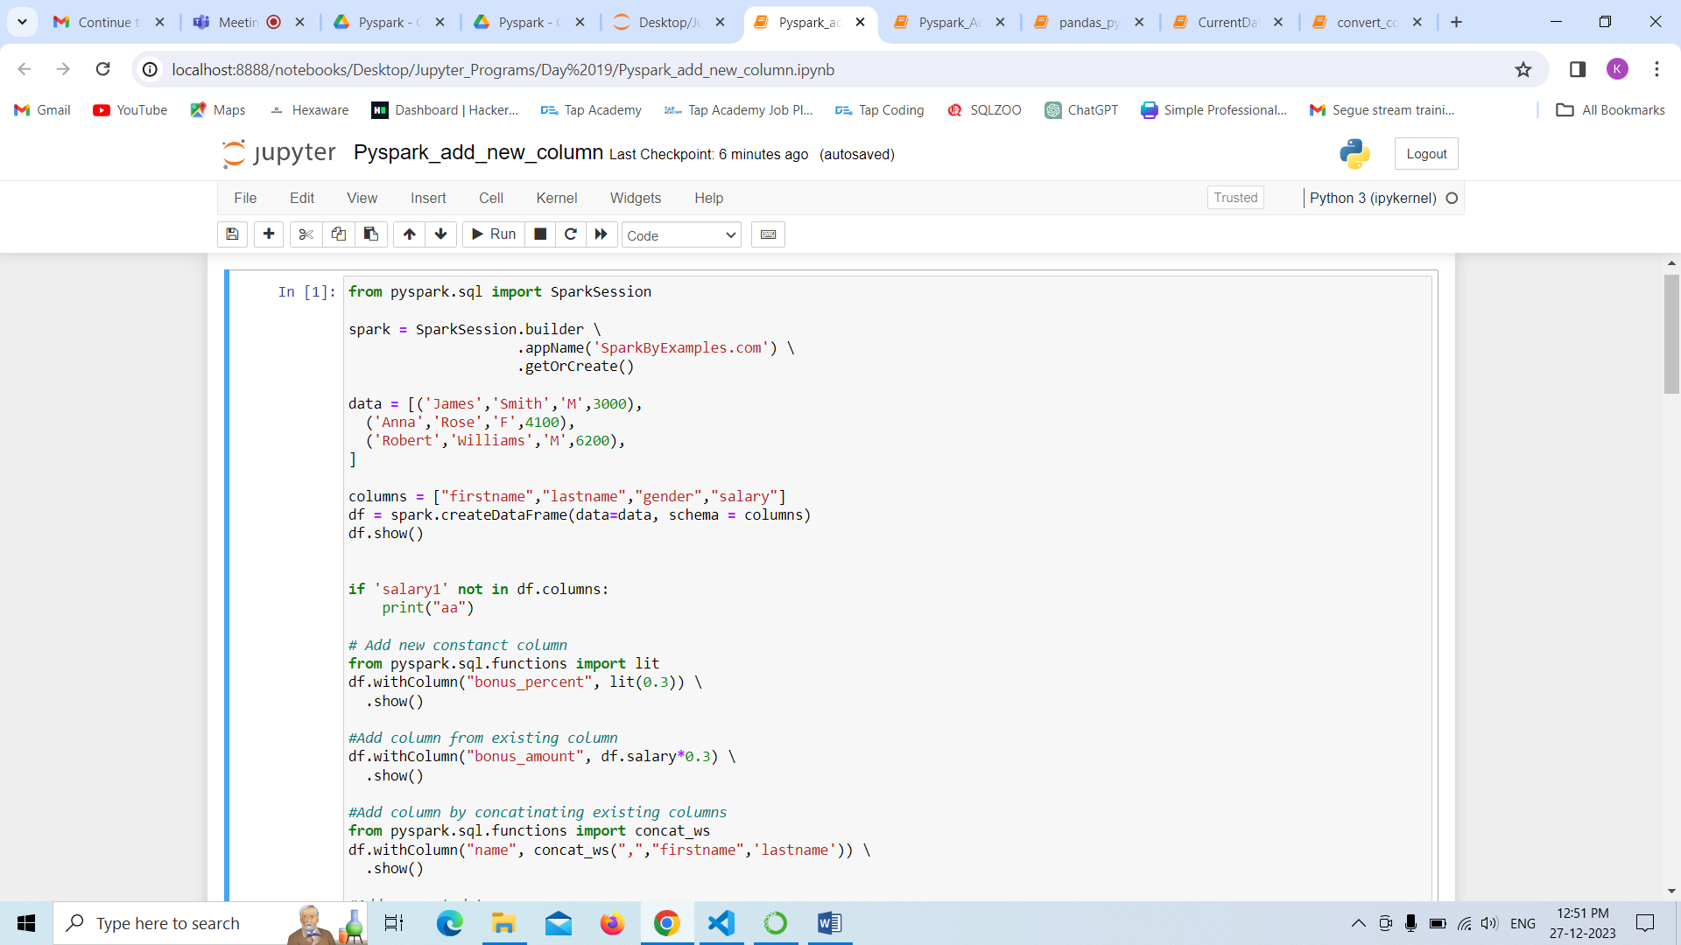

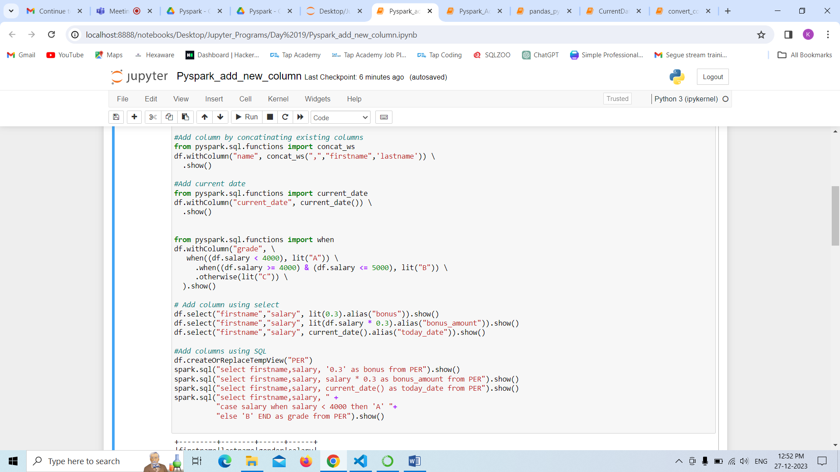

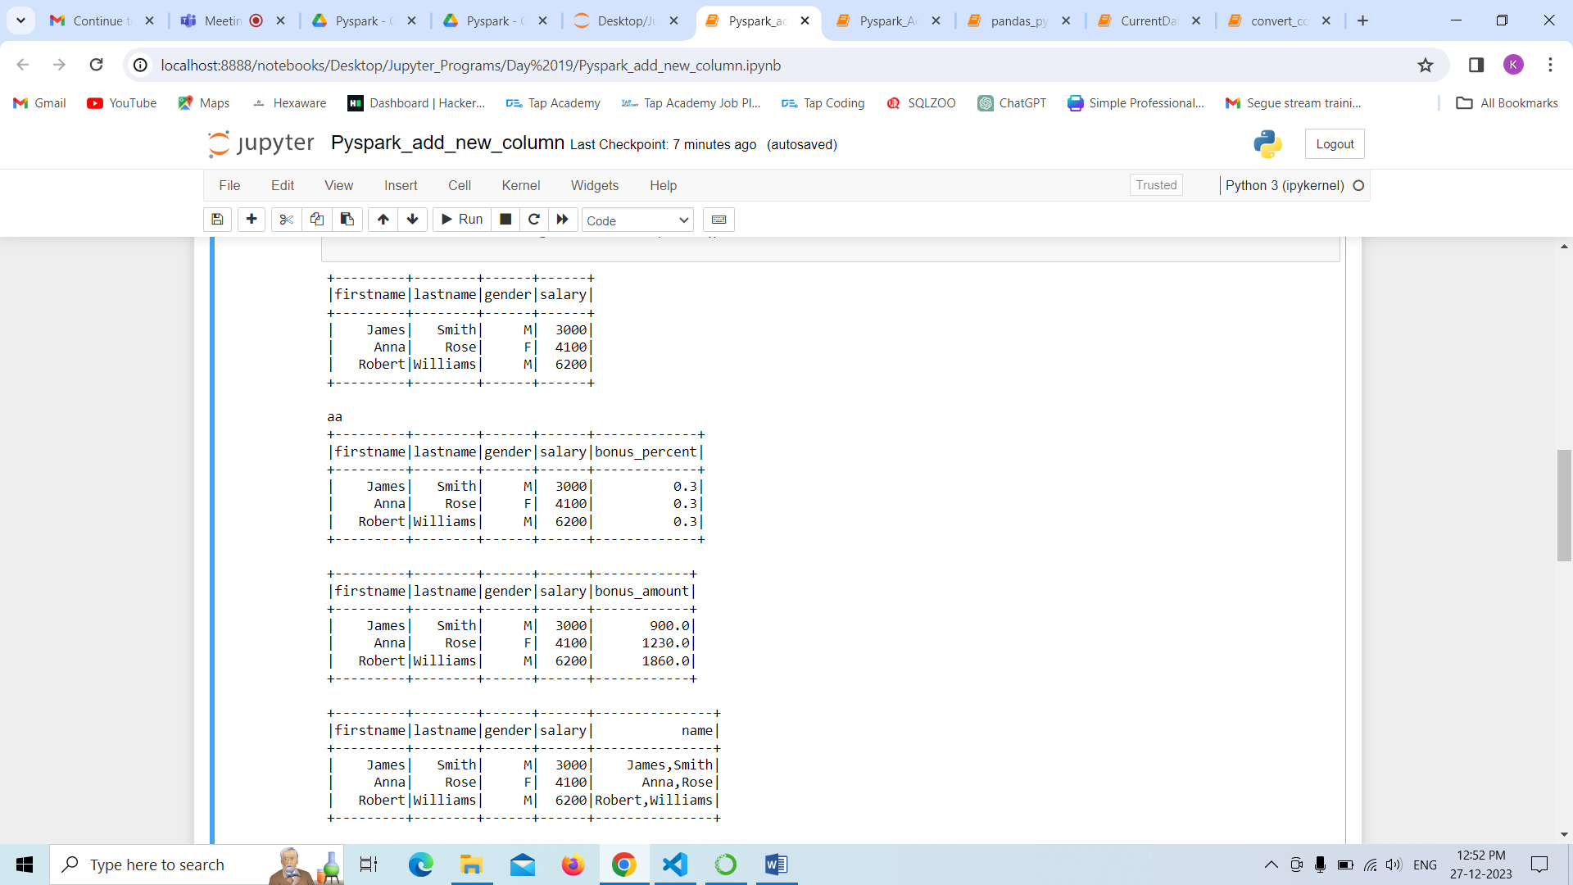

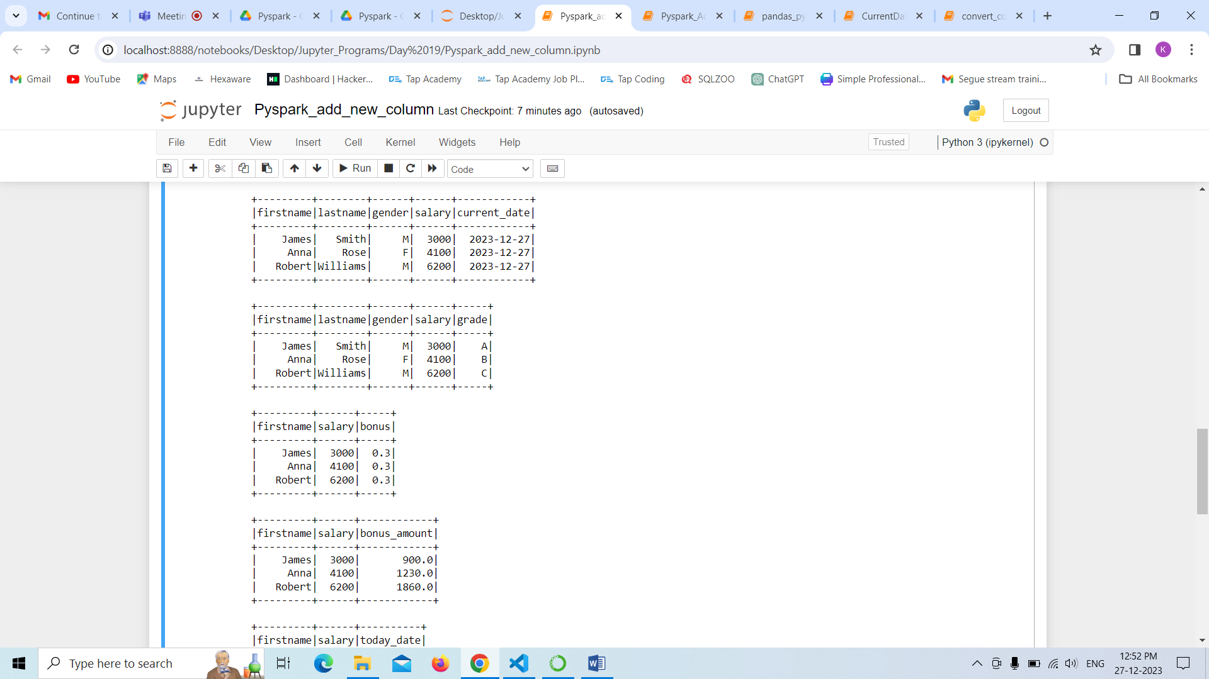

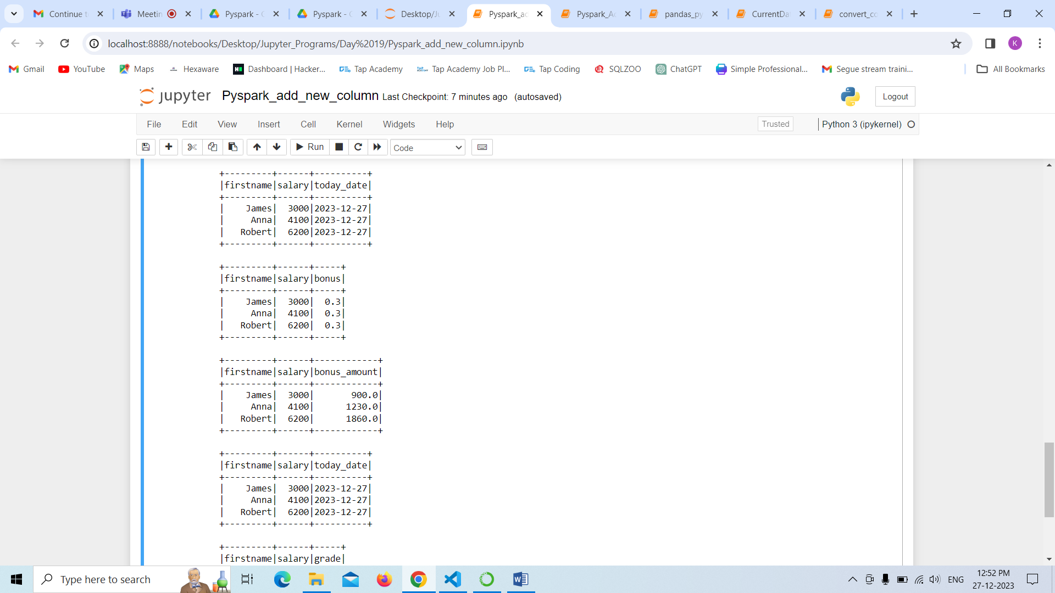

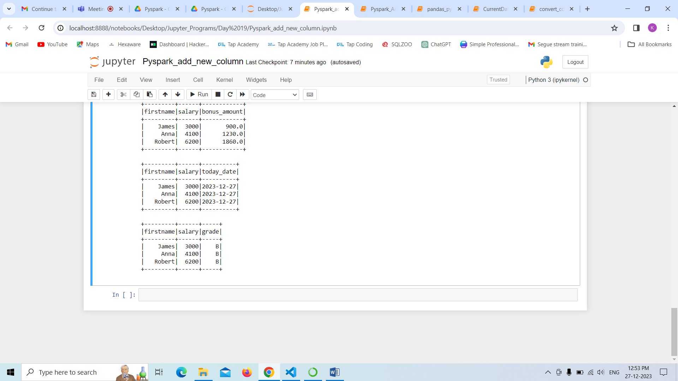

In this program we are performing the aggregate functions to the existing table in the pyspark environment with the help of SparkSession Class.we are calculating aggregating functions like max,min,avg,count,sum and displaying data in the table format.

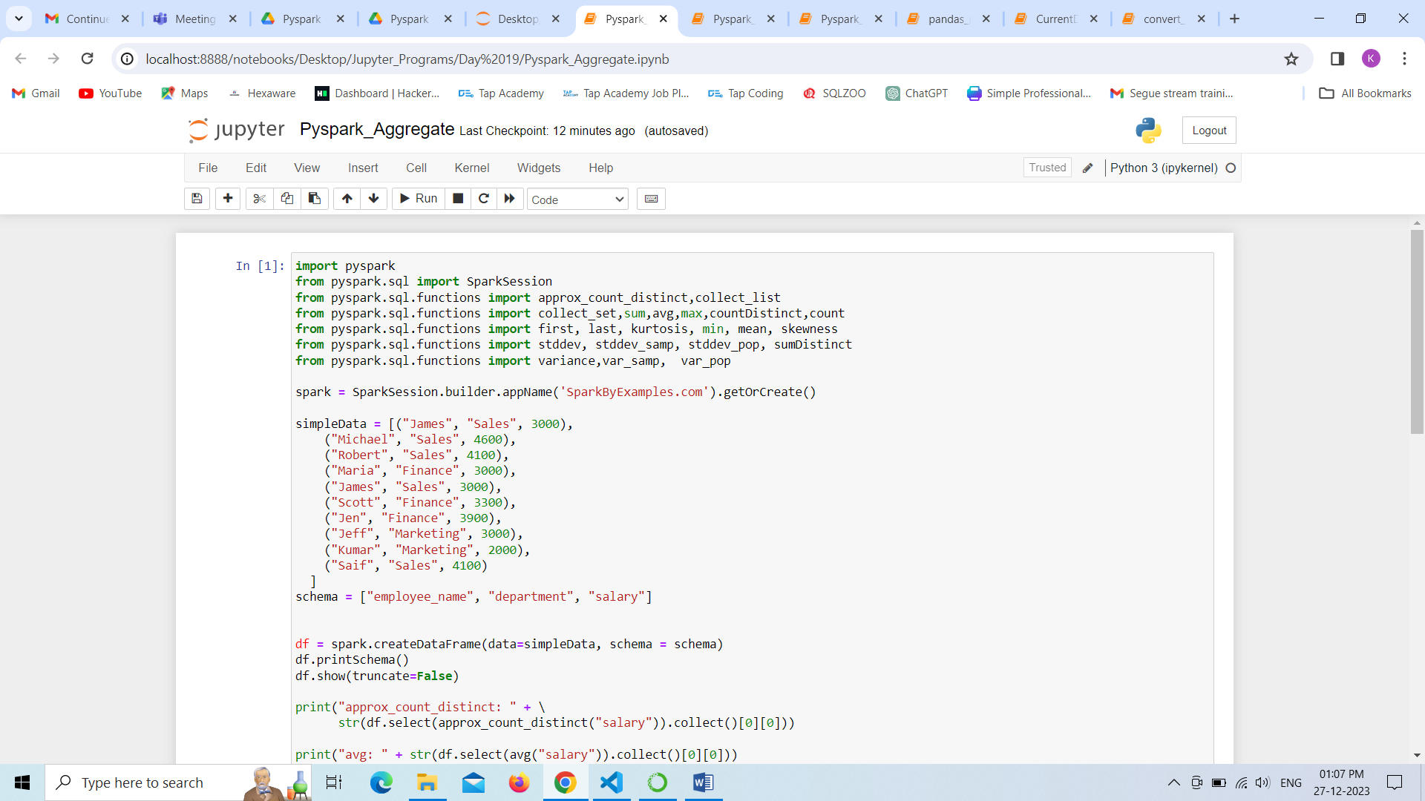

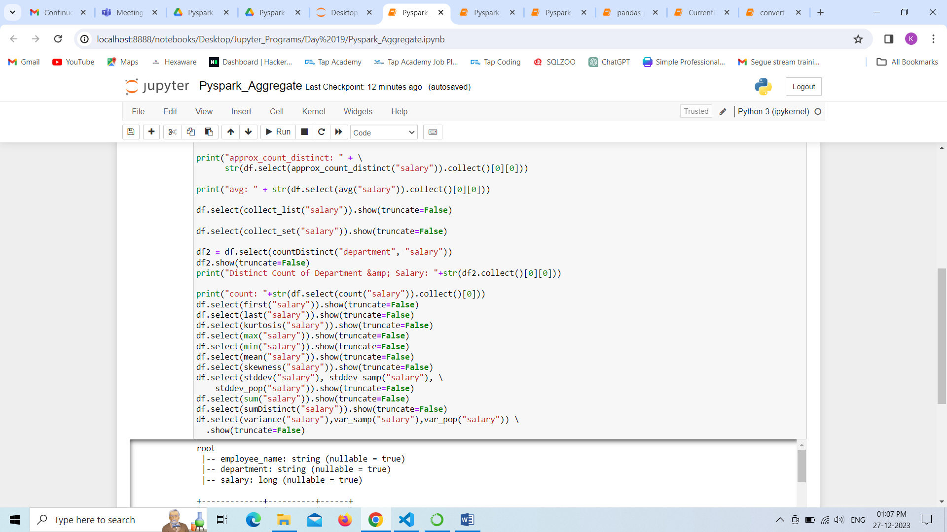

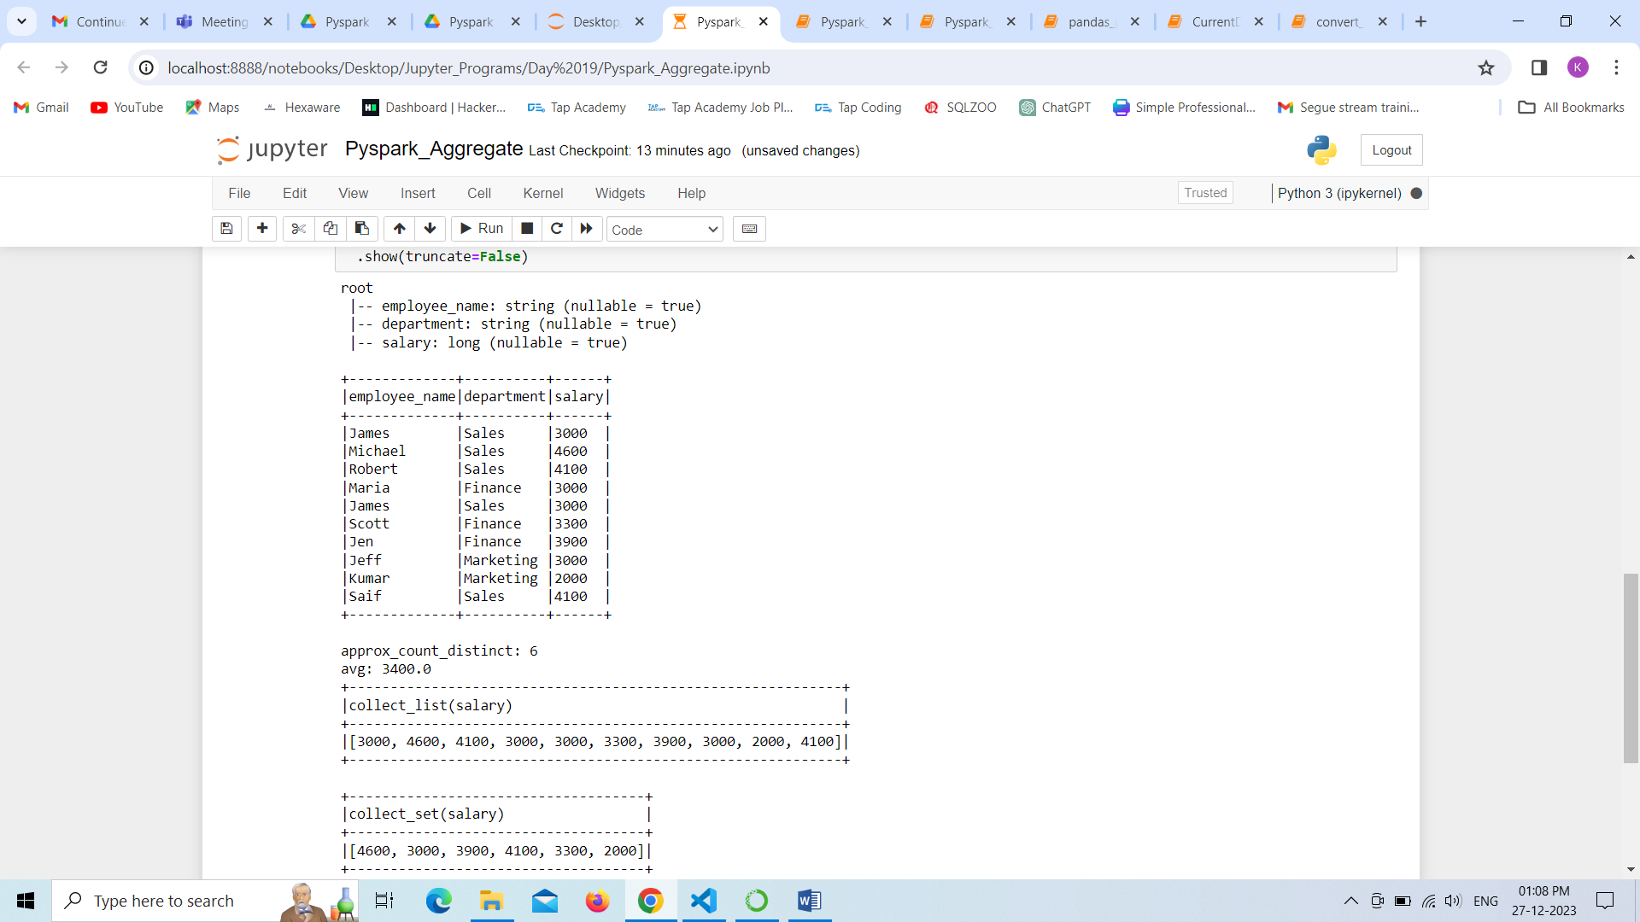

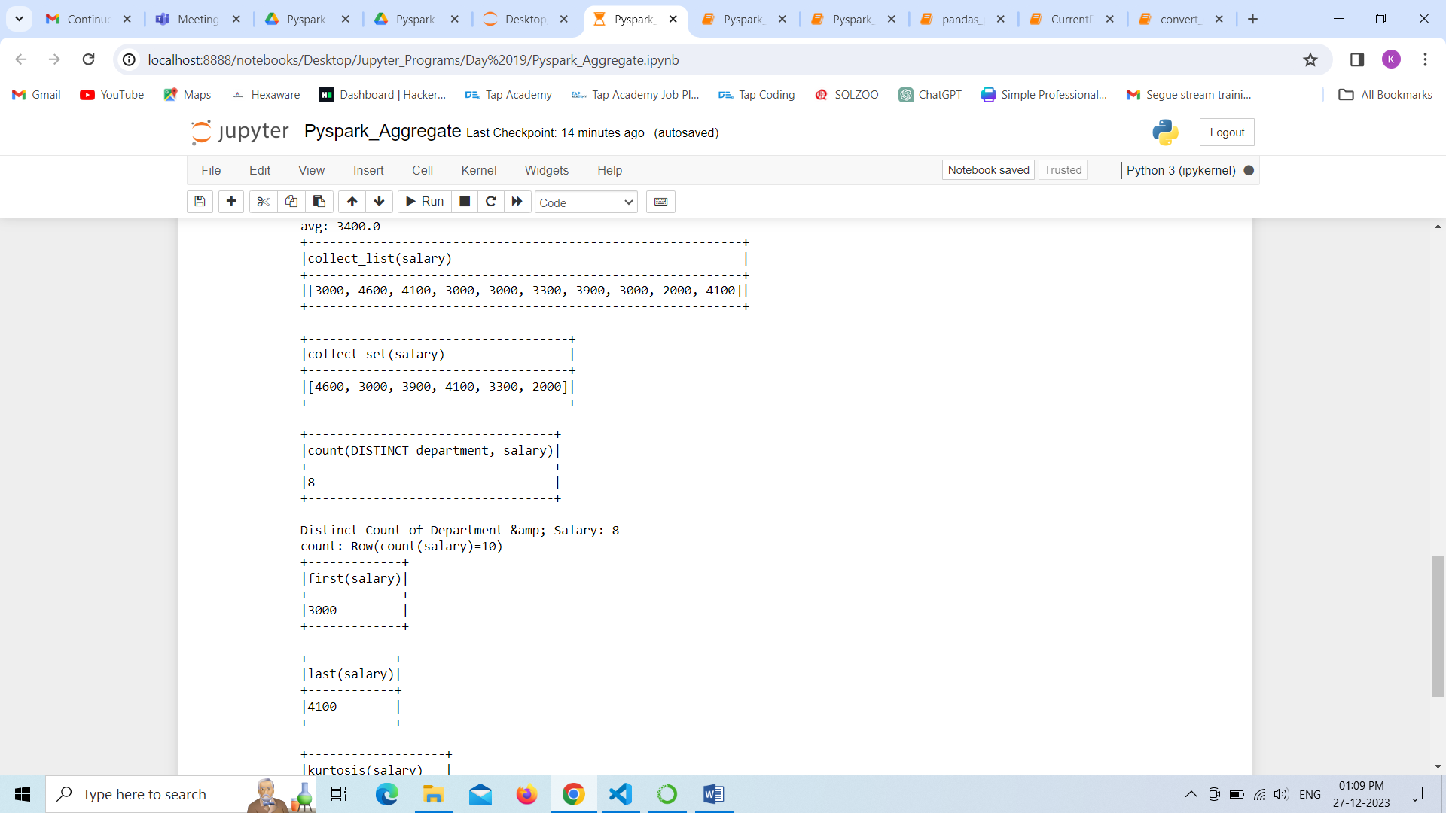

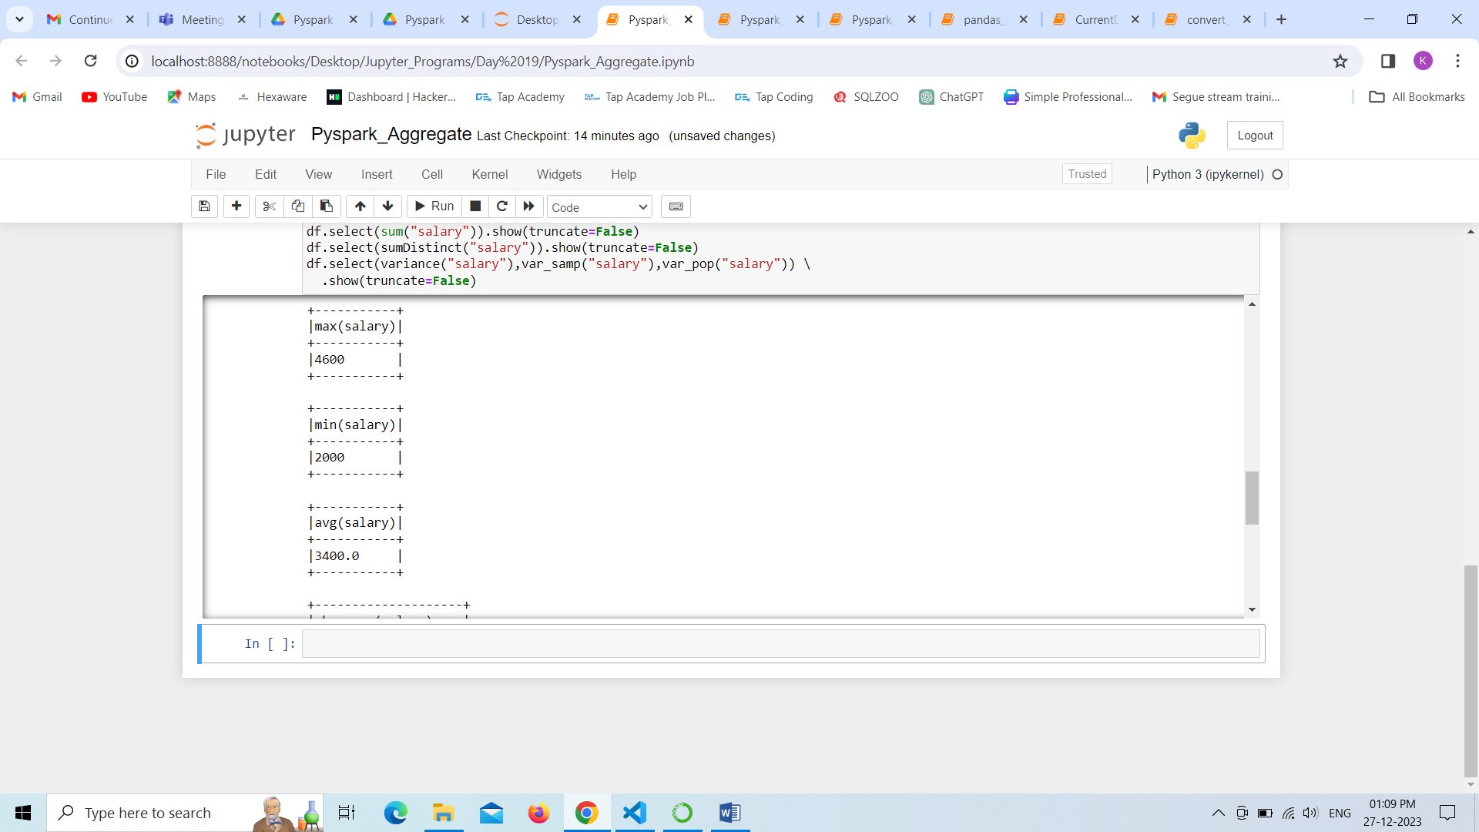

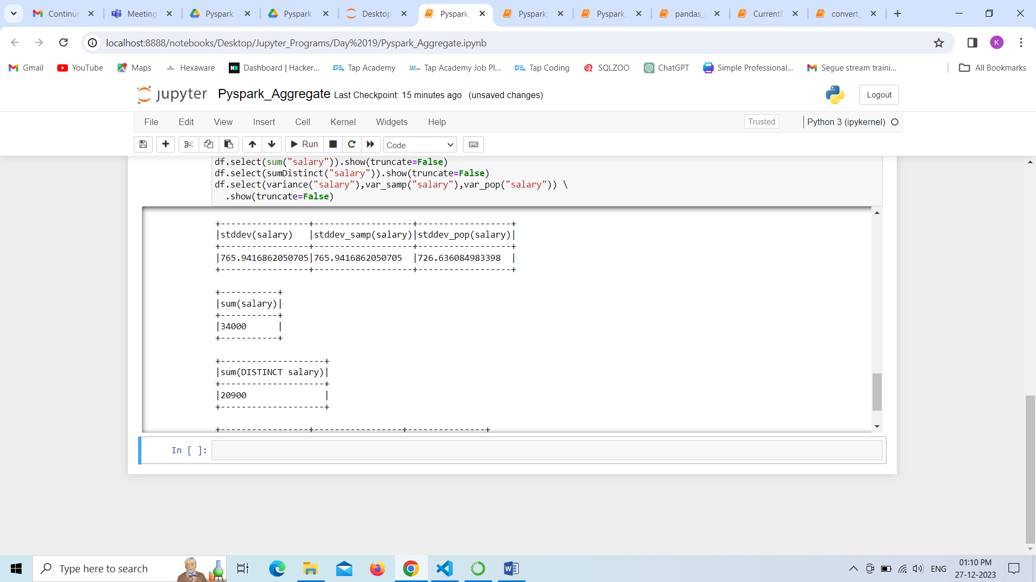

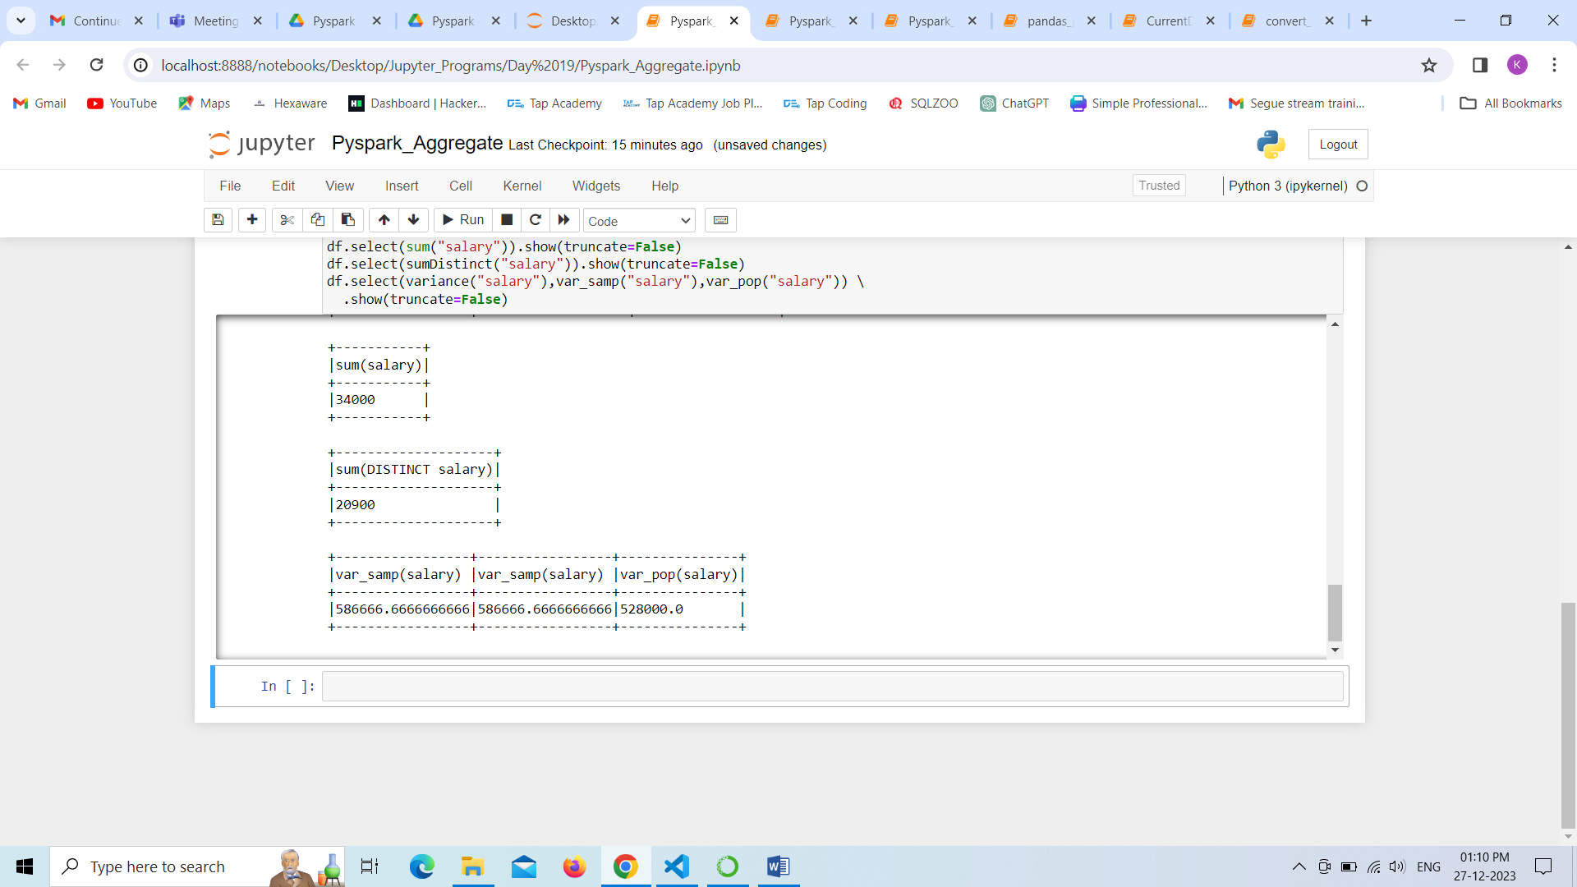

In this program ,we can perform arrays of string to the existing table in the pyspark environment with the help of SparkSession Class. we displaying data.

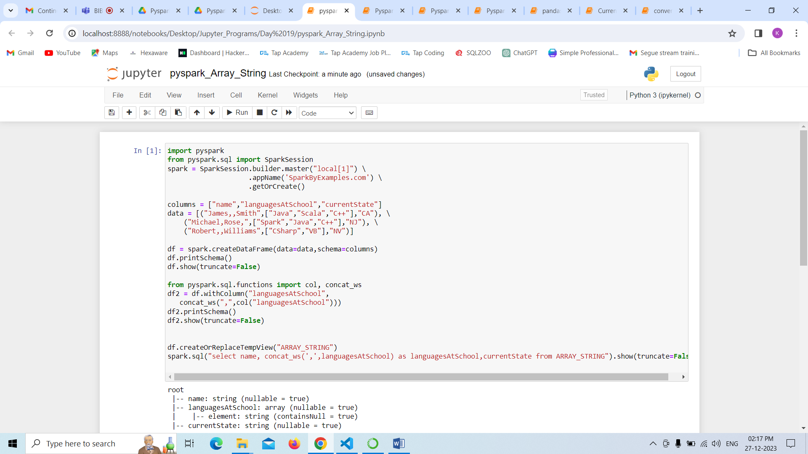

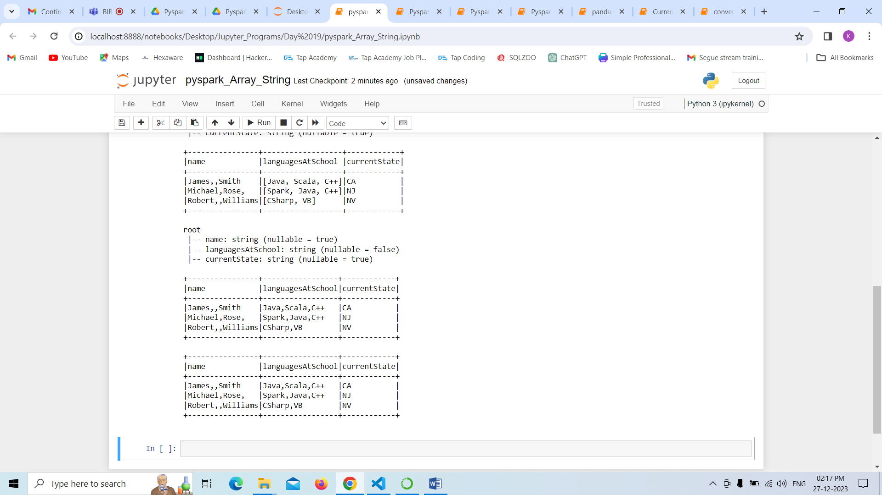

In this program ,we can perform arrays to the existing table in the pyspark environment with the help of SparkSession Class. we displaying data.

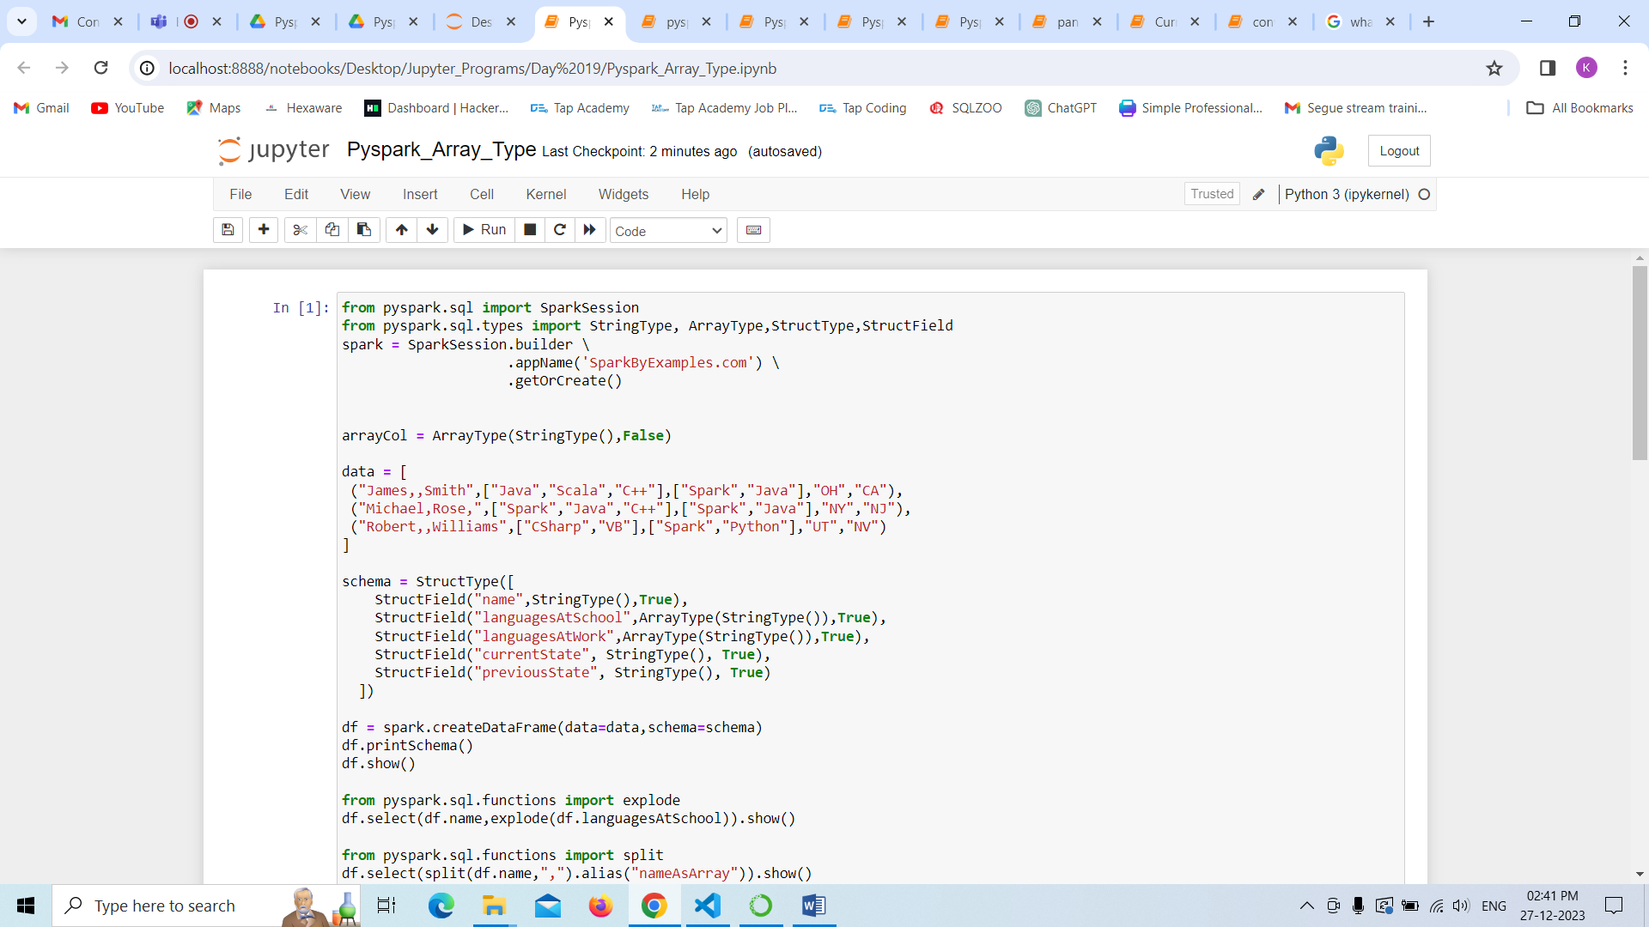

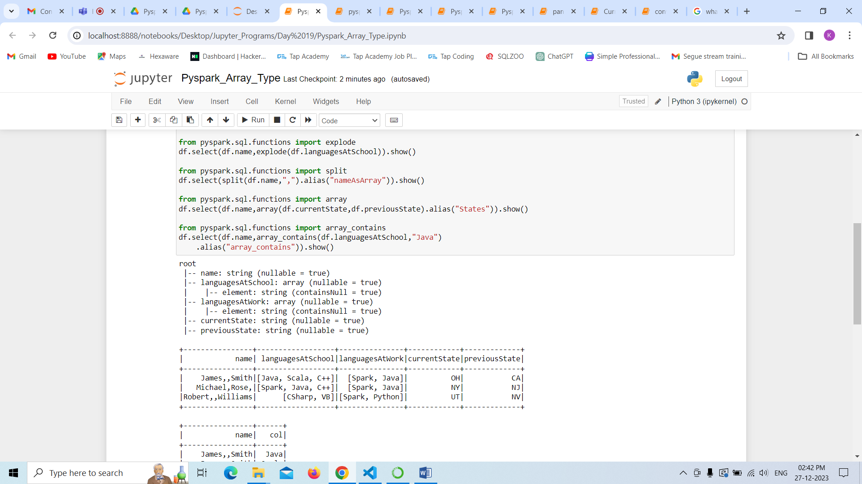

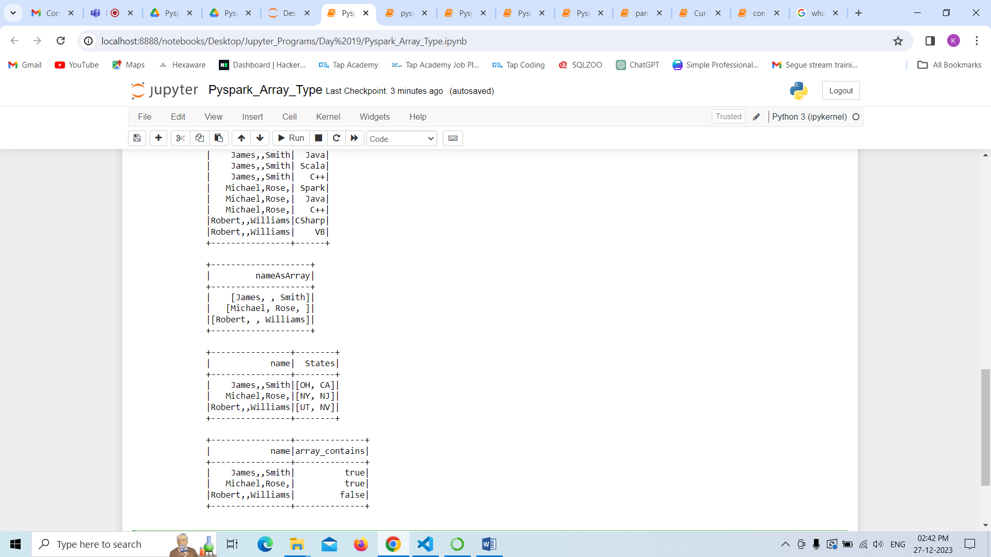

In PySpark, we can cast or change the DataFrame column data type using cast() function of Column class.

